##### --1.How many customers do we have in the data?

*SELECT*

*COUNT(DISTINCT customer_id) AS number_of_customers*

*FROM customers;*

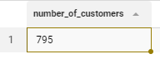

##### -- 2.What was the city with the most profit for the company in 2015?

*WITH most_profitable_cities AS (*

*SELECT*

*o.shipping_city,*

*SUM(od.order_profits) AS profit_in_2015*

*FROM orders o*

*JOIN order_details od*

*ON o.order_id=od.order_id*

*WHERE EXTRACT (YEAR FROM o.order_date)=2015*

*GROUP BY o.shipping_city*

*ORDER BY profit_in_2015 DESC)*

*SELECT*

*shipping_city AS city_with_the_most_profit_in_2015*

*FROM*

*most_profitable_cities*

*LIMIT 1;*



##### 

##### -- 3.In 2015, what was the most profitable city's profit?

*WITH most_profitable_cities AS (*

*SELECT*

*o.shipping_city,*

*SUM(od.order_profits) AS profit_in_2015*

*FROM orders o*

*JOIN order_details od*

*ON o.order_id=od.order_id*

*WHERE EXTRACT (YEAR FROM o.order_date)=2015*

*GROUP BY o.shipping_city*

*ORDER BY profit_in_2015 DESC*

*LIMIT 1)*

*SELECT*

*profit_in_2015 AS most_profitable_citys_profit_in_2015*

*FROM most_profitable_cities;*

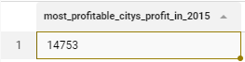

##### -- 4.How many different cities do we have in the data?

*SELECT*

*COUNT(DISTINCT shipping_city) AS number_of_unique_cities*

*FROM orders;*

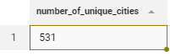

##### 

##### -- 5.Show the total spent by customers from low to high.

*SELECT*

*o.customer_id,*

*c.customer_name,*

*c.customer_segment,*

*SUM(od.order_sales) AS total_spent*

*FROM orders o*

*JOIN order_details od*

*ON o.order_id=od.order_id*

*JOIN customers c*

*ON o.customer_id=c.customer_id*

*GROUP BY o.customer_id, c.customer_name, c.customer_segment*

*ORDER BY total_spent;*

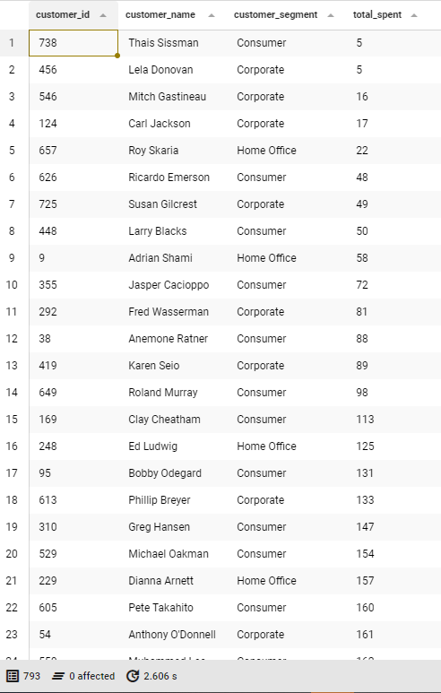

##### 

##### --6. What is the most profitable city in the State of Tennessee?

*SELECT*

*orders.shipping_city*

*FROM orders*

*JOIN order_details USING(order_id)*

*WHERE shipping_state = 'Tennessee'*

*GROUP BY orders.shipping_city*

*ORDER BY SUM(order_details.order_profits) DESC*

*LIMIT 1;*



##### --7. What’s the average annual profit for that city across all years?

*SELECT*

*o.shipping_city,*

*ROUND(AVG(od.order_profits::NUMERIC),2) AS average_profit_of_Lebanon*

*FROM orders o*

*JOIN order_details od*

*ON o.order_id=od.order_id*

*WHERE o.shipping_city='Lebanon'*

*GROUP BY o.shipping_city --, year*

*ORDER BY average_profit_of_Lebanon DESC;*



##### --8. What is the distribution of customer types in the data?

*SELECT*

*customer_segment, COUNT(*),*

*ROUND(*

*COUNT(*)*100.0 / SUM(COUNT(*)) OVER ()*

*, 2) AS percent_distribution*

*FROM customers*

*GROUP BY customer_segment;*

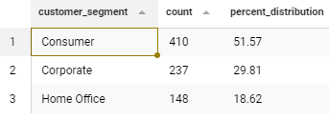

*WITH number_of_orders AS (*

*SELECT DISTINCT*

*c.customer_id,*

*COUNT(DISTINCT o.order_id) AS number_of_orders_by_customer*

*FROM customers c*

*JOIN orders o*

*ON c.customer_id=o.customer_id*

*JOIN order_details od*

*ON o.order_id=od.order_id*

*JOIN product p*

*ON od.product_id=p.product_id*

*GROUP BY c.customer_id*

*)*

*SELECT--Quartiles - query (averages)*

*ROUND (PERCENTILE_CONT(0.25) WITHIN GROUP (ORDER BY number_of_orders_by_customer ASC) :: NUMERIC,2) AS orders_p25,*

*ROUND (PERCENTILE_CONT (0.5) WITHIN GROUP (ORDER BY number_of_orders_by_customer ASC) :: NUMERIC,2) AS orders_p50,*

*ROUND (PERCENTILE_CONT (0.75) WITHIN GROUP (ORDER BY number_of_orders_by_customer ASC) :: NUMERIC,2) AS orders_p75,*

*ROUND(AVG (number_of_orders_by_customer) :: NUMERIC, 2) AS avg_orders*

*FROM number_of_orders;*

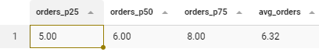

##### --9. What’s the most profitable product category on average in Iowa across all years?

*SELECT*

*p.product_category*

*FROM order_details od*

*JOIN orders o*

*ON od.order_id = o.order_id*

*JOIN product p*

*ON od.product_id = p.product_id*

*WHERE o.shipping_state ILIKE 'iowa%'*

*GROUP BY p.product_category*

*ORDER BY AVG(od.order_profits) DESC*

*LIMIT 1;*

**

##### --10 What is the most popular product in that category across all states in 2016?

*WITH quantity AS(*

*SELECT DISTINCT*

*p.product_name,*

*SUM(od.quantity) AS total_quantity_of_products*

*FROM orders o*

*JOIN order_details od*

*ON o.order_id=od.order_id*

*JOIN product p*

*ON od.product_id=p.product_id*

*WHERE EXTRACT (YEAR FROM o.order_date)=2016 AND p.product_category='Furniture'*

*GROUP BY p.product_name)*

*SELECT*

*product_name AS the_most_popular_product_in_Furniture_in_2016*

*FROM quantity*

*ORDER BY total_quantity_of_products DESC*

*LIMIT 1;*

**

##### --11. Which customer got the most discount in the data? (in total amount)

*WITH discount AS(*

*SELECT DISTINCT*

*c.customer_id,*

*c.customer_name,*

*c.customer_segment,*

*SUM(od.order_sales*od.order_discount) AS amount_of_discount*

*FROM customers c*

*JOIN orders o*

*ON c.customer_id=o.customer_id*

*JOIN order_details od*

*ON o.order_id=od.order_id*

*JOIN product p*

*ON od.product_id=p.product_id*

*GROUP BY c.customer_id,c.customer_name,c.customer_segment)*

*SELECT*

*customer_id, customer_name, customer_segment*

*FROM discount*

*ORDER BY amount_of_discount DESC*

*LIMIT 1;*



##### 

##### --12. How widely did monthly profits vary in 2018?

*WITH monthly_profit AS (*

*SELECT*

*EXTRACT (MONTH FROM order_date) AS months_number,*

*TO_CHAR (order_date, 'Month') AS months,*

*SUM(order_profits) AS profit*

*FROM orders*

*JOIN order_details USING (order_id)*

*WHERE EXTRACT (YEAR FROM order_date) = 2018*

*GROUP BY months_number, months*

*ORDER BY months_number*

*)*

*SELECT*

*months,*

*profit,*

*profit - LAG (profit, 1, 0) OVER() AS profit_variations*

*FROM monthly_profit;*

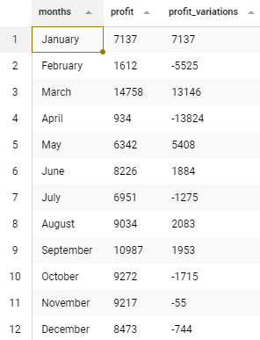

##### --13. Which was the biggest order regarding sales in 2015?

*SELECT order_id*

*FROM order_details*

*JOIN orders USING (order_id)*

*WHERE DATE_PART('year', order_date)=2015*

*GROUP BY order_id*

*ORDER BY SUM(order_sales) DESC*

*LIMIT 1;*



##### 

##### --14 What was the rank of each city in the East region in 2015 in quantity?

*SELECT*

*shipping_city, SUM(quantity),*

*RANK() OVER (ORDER BY SUM(quantity) DESC) AS city_rank*

*FROM*

*orders o*

*JOIN order_details od*

*ON o.order_id = od.order_id*

*WHERE*

*shipping_region = 'East'*

*AND EXTRACT(YEAR FROM order_date) = 2015*

*GROUP BY*

*shipping_city*

*ORDER BY*

*SUM(quantity) DESC;*

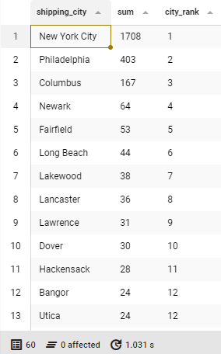

##### --15. Display customer names for customers who are in the segment ‘Consumer’ or ‘Corporate.’ How many customers are there in total?

*SELECT*

*customer_segment,*

*customer_name,*

*COUNT(customer_id) OVER (PARTITION BY customer_segment) AS category_count,*

*COUNT(customer_id) OVER () AS total_customers*

*FROM customers*

*WHERE customer_segment IN ('Consumer', 'Corporate');*

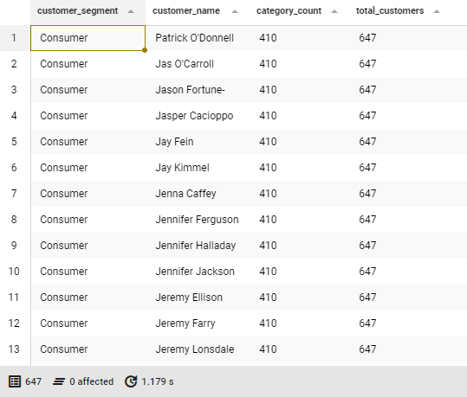

##### --16. Calculate the difference between the largest and smallest order quantities for product id ‘100.’

*SELECT*

*MAX(quantity) - MIN(quantity) AS difference*

*FROM order_details*

*WHERE product_id = 100*

*GROUP BY product_id;*



##### --17. Calculate the percent of products that are within the category ‘Furniture.’

*SELECT percentage*

*FROM (*

*SELECT product_category,*

*ROUND(*

*SUM(COUNT(*)) OVER (PARTITION BY product_category)*100.0/SUM(COUNT(*)) OVER ()*

*,2) AS percentage*

*FROM product*

*GROUP BY product_category*

*)AS sub*

*WHERE product_category = 'Furniture';*



##### --18. Display the number of product manufacturers with more than 1 product in the product table.

*SELECT COUNT(product_manufacturer) as total_number_of_manufacturers*

*FROM (*

*SELECT product_manufacturer*

*FROM product*

*GROUP BY product_manufacturer*

*HAVING COUNT(product_id)>1*

*) AS sub;*



##### --19. Show the product_subcategory and the total number of products in the subcategory.

##### – Show the order from most to least products and then by product_subcategory name ascending.

*SELECT*

*product_subcategory,*

*COUNT(product_id) AS products_quantity*

*FROM product*

*GROUP BY product_subcategory*

*ORDER BY products_quantity DESC, product_subcategory;*

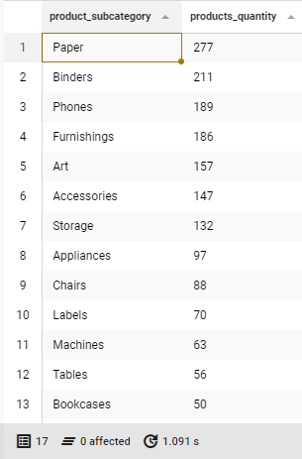

##### --20. Show the product_id(s), the sum of quantities, where the total sum of its product quantities is greater than or equal to 100.

*SELECT*

*product_id,*

*SUM(quantity) AS sum_of_quantity*

*FROM order_details*

*JOIN orders USING (order_id)*

*GROUP BY product_id*

*HAVING SUM(quantity)>=100;*

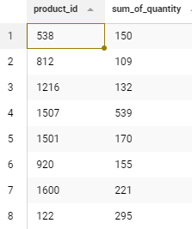

##### --Bonus question: Join all database tables into one dataset that includes all unique columns and download it as a .csv file.

SELECT

c.customer_id,

c.customer_name,

c.customer_segment,

od.order_details_id,

od.order_id,

od.quantity,

od.order_discount,

od.order_profits,

od.order_profit_ratio,

od.order_sales,

o.order_date,

o.shipping_city,

o.shipping_state,

o.shipping_region,

o.shipping_country,

o.shipping_postal_code,

o.order_date,

o.shipping_mode,

p.product_name,

p.product_category,

p.product_subcategory,

p.product_manufacturer

FROM customers c

JOIN orders o

ON c.customer_id=o.customer_id

JOIN order_details od

ON o.order_id=od.order_id

JOIN product p

ON od.product_id=p.product_id;